1

Code:

libname college 'C:\Users\Samil\Desktop\Sem 1\Stats for programming\SAS 9.4';

/*Sorting the datasets*/

**proc** **sort** data=college.cats2;

by cat;

**run**;

**proc** **sort** data=college.cats3;

by cat;

**run**;

**proc** **sort** data=college.cats;

by cat;

**run**;

/*combing cats2 and cat3*/

**data** college.cats23;

set college.cats2 college.cats3;

drop Week_2 Week_1;

**run**;

**proc** **sort** data=college.cats23;

by cat;

**run**;

/*Merging cats 1 2 3*/

**data** college.cats123;

merge college.cats college.cats23;

by cat;

if position=side then treated=week_0;

else untreated=week_0;

drop week_0 position side;

**run**;

/*Treated dataset*/

**data** treated;

set college.cats123;

by cat;

where treated^=**.**;

drop untreated;

**run**;

/*Untreated dataset*/

**data** untreated;

set college.cats123;

by cat;

where untreated^=**.**;

drop treated;

**run**;

**data** animals;

merge treated untreated;

by cat;

**run**;

**proc** **print** data=animals;

**run**;

Title;

Log File:

483 libname college 'C:\Users\Samil\Desktop\Sem 1\Stats for programming\SAS 9.4';

NOTE: Libref COLLEGE was successfully assigned as follows:

Engine: V9

Physical Name: C:\Users\Samil\Desktop\Sem 1\Stats for programming\SAS 9.4

484

485 /*Sorting the datasets*/

486 proc sort data=college.cats2;

487 by cat;

488 run;

NOTE: Input data set is already sorted, no sorting done.

NOTE: PROCEDURE SORT used (Total process time):

real time 0.00 seconds

cpu time 0.00 seconds

489

490 proc sort data=college.cats3;

491 by cat;

492 run;

NOTE: Input data set is already sorted, no sorting done.

NOTE: PROCEDURE SORT used (Total process time):

real time 0.00 seconds

cpu time 0.00 seconds

493

494 proc sort data=college.cats;

495 by cat;

496 run;

NOTE: Input data set is already sorted, no sorting done.

NOTE: PROCEDURE SORT used (Total process time):

real time 0.00 seconds

cpu time 0.01 seconds

497

498 /*combing cats2 and cat3*/

499 data college.cats23;

500 set college.cats2 college.cats3;

501 drop Week_2 Week_1;

502 run;

WARNING: Multiple lengths were specified for the variable Side by input data set(s). This can

cause truncation of data.

NOTE: There were 8 observations read from the data set COLLEGE.CATS2.

NOTE: There were 8 observations read from the data set COLLEGE.CATS3.

NOTE: The data set COLLEGE.CATS23 has 16 observations and 3 variables.

NOTE: DATA statement used (Total process time):

real time 0.02 seconds

cpu time 0.01 seconds

503

504 proc sort data=college.cats23;

505 by cat;

506 run;

NOTE: There were 16 observations read from the data set COLLEGE.CATS23.

NOTE: The data set COLLEGE.CATS23 has 16 observations and 3 variables.

NOTE: PROCEDURE SORT used (Total process time):

real time 0.01 seconds

cpu time 0.00 seconds

507

508 /*Merging cats 1 2 3*/

509 data college.cats123;

510 merge college.cats college.cats23;

511 by cat;

512 if position=side then treated=week_0;

513 else untreated=week_0;

514 drop week_0 position side;

515 run;

NOTE: There were 8 observations read from the data set COLLEGE.CATS.

NOTE: There were 16 observations read from the data set COLLEGE.CATS23.

NOTE: The data set COLLEGE.CATS123 has 16 observations and 3 variables.

NOTE: DATA statement used (Total process time):

real time 0.01 seconds

cpu time 0.03 seconds

516

517 /*Treated dataset*/

518 data treated;

519 set college.cats123;

520 by cat;

521 where treated^=.;

522 drop untreated;

523 run;

NOTE: There were 8 observations read from the data set COLLEGE.CATS123.

WHERE treated not = .;

NOTE: The data set WORK.TREATED has 8 observations and 2 variables.

NOTE: DATA statement used (Total process time):

real time 0.10 seconds

cpu time 0.01 seconds

524

525 /*Untreated dataset*/

526 data untreated;

527 set college.cats123;

528 by cat;

529 where untreated^=.;

530 drop treated;

531 run;

NOTE: There were 8 observations read from the data set COLLEGE.CATS123.

WHERE untreated not = .;

NOTE: The data set WORK.UNTREATED has 8 observations and 2 variables.

NOTE: DATA statement used (Total process time):

real time 0.03 seconds

cpu time 0.00 seconds

532

533 data animals;

534 merge treated untreated;

535 by cat;

536 run;

NOTE: There were 8 observations read from the data set WORK.TREATED.

NOTE: There were 8 observations read from the data set WORK.UNTREATED.

NOTE: The data set WORK.ANIMALS has 8 observations and 3 variables.

NOTE: DATA statement used (Total process time):

real time 0.03 seconds

cpu time 0.03 seconds

537

538 proc print data=animals;

539 run;

NOTE: There were 8 observations read from the data set WORK.ANIMALS.

NOTE: PROCEDURE PRINT used (Total process time):

real time 0.12 seconds

cpu time 0.01 seconds

Output:

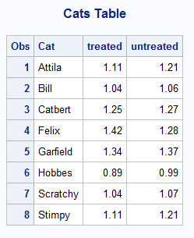

2

Code:

**data** team;

set college.soccer;

meter=Feet\***0.3048**+inches\***0.0254**;

format meter **4.2**;

**run**;

Title 'Soccer Team';

**proc** **print** data=team;

var firstname lastname jersey meter;

**run**;

Title;

Log File:

628 data team;

629 set college.soccer;

630 meter=Feet*0.3048+inches*0.0254;

631 format meter 4.2;

632 run;

NOTE: Character values have been converted to numeric values at the places given by:

(Line):(Column).

630:8

NOTE: There were 32 observations read from the data set COLLEGE.SOCCER.

NOTE: The data set WORK.TEAM has 32 observations and 9 variables.

NOTE: DATA statement used (Total process time):

real time 0.01 seconds

cpu time 0.01 seconds

633 Title 'Soccer Team';

634

635 proc print data=team;

636 var firstname lastname jersey meter;

637 run;

NOTE: There were 32 observations read from the data set WORK.TEAM.

NOTE: PROCEDURE PRINT used (Total process time):

real time 0.19 seconds

cpu time 0.01 seconds

638

639 Title;

Output:

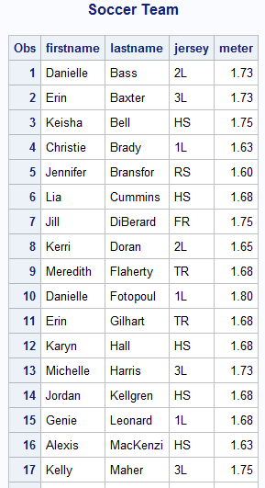

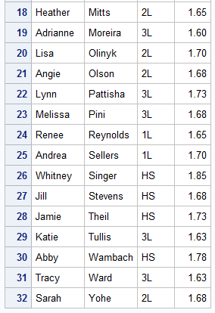

3

Code:

/*proc print data=college.hockey;

run;*/

**proc** **sort** data=college.hockey;

by team;

**run**;

**data** hockeymod1;

set college.hockey;

by Team;

if Team='Boston College' then OPP=**5**;

*set hockeymod1;

if Team='Boston College' then OSU=**2**;

day=day(Date);

month=month(Date);

year=year(Date);

Date2=mdy(month,day,year);

format Date2 mmddyy10.;

**run**;

Title 'Hockey Team';

**proc** **print** data=hockeymod1;

**run**;

Title;

Log file:

393 /*proc print data=college.hockey;

394 run;*/

395

396 proc sort data=college.hockey;

397 by team;

398 run;

NOTE: Input data set is already sorted, no sorting done.

NOTE: PROCEDURE SORT used (Total process time):

real time 0.05 seconds

cpu time 0.01 seconds

399

400 data hockeymod1;

401 set college.hockey;

402 by Team;

403 if Team='Boston College' then OPP=5;

404 *set hockeymod1;

405 if Team='Boston College' then OSU=2;

406 day=day(Date);

407 month=month(Date);

408 year=year(Date);

409 Date2=mdy(month,day,year);

410 format Date2 mmddyy10.;

411 run;

NOTE: There were 36 observations read from the data set COLLEGE.HOCKEY.

NOTE: The data set WORK.HOCKEYMOD1 has 36 observations and 10 variables.

NOTE: DATA statement used (Total process time):

real time 0.03 seconds

cpu time 0.03 seconds

412

413 Title 'Hockey Team';

414

415 proc print data=hockeymod1;

416 run;

NOTE: There were 36 observations read from the data set WORK.HOCKEYMOD1.

NOTE: PROCEDURE PRINT used (Total process time):

real time 0.16 seconds

cpu time 0.04 seconds

417

418 Title;

Output:

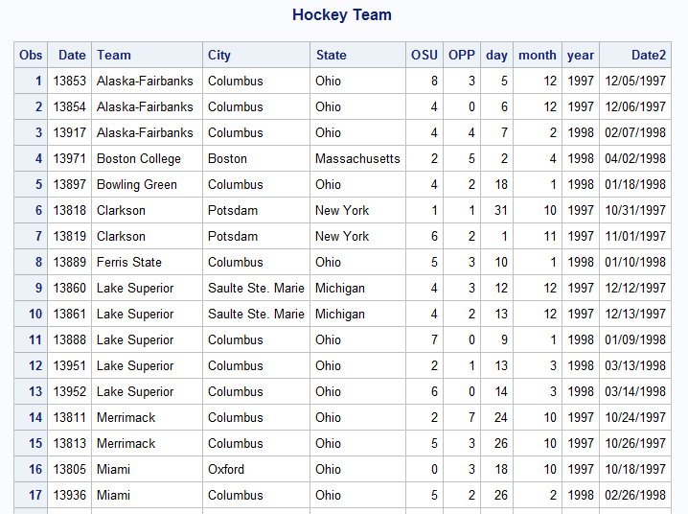

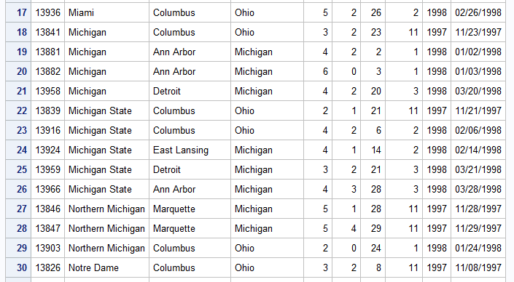

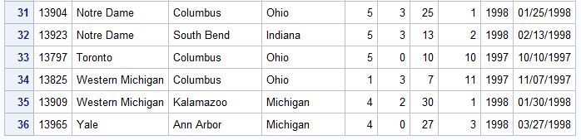

4

Code:

**data** college.usedcars;

infile 'C:\Users\Samil\Desktop\Sem 1\Stats for programming\SAS 9.4\usedcars.txt' firstobs=**2** obs=**51** expandtabs ;

input Year **1**-**3** Manufacturer $ **9**-**22** Model $ **24**-**36** @**38** Miles comma7.0 @**49** Price dollar8.0 Dealer $**61**-**84**;

format Price dollar8.0;

**run**;

**proc** **sort** data=college.usedcars;

by Dealer Price;

**run**;

Title 'Usedcars';

**data** carsused;

set college.usedcars;

by Dealer;

*The function first fetches the first member of the group;

if first.Dealer;

drop miles;

**run**;

**proc** **print** data=carsused;

**run**;

Title;

Log file:

42 data college.usedcars;

43 infile 'C:\Users\Samil\Desktop\Sem 1\Stats for programming\SAS 9.4\usedcars.txt' firstobs=2

43 ! obs=51 expandtabs ;

44 input Year 1-3 Manufacturer $ 9-22 Model $ 24-36 @38 Miles comma7.0 @49 Price dollar8.0

44 ! Dealer $61-84;

45 format Price dollar8.0;

46 run;

NOTE: The infile 'C:\Users\Samil\Desktop\Sem 1\Stats for programming\SAS 9.4\usedcars.txt' is:

Filename=C:\Users\Samil\Desktop\Sem 1\Stats for programming\SAS 9.4\usedcars.txt,

RECFM=V,LRECL=32767,File Size (bytes)=4743,

Last Modified=19 September 2017 22:29:21,

Create Time=19 September 2017 22:29:21

NOTE: 50 records were read from the infile 'C:\Users\Samil\Desktop\Sem 1\Stats for

programming\SAS 9.4\usedcars.txt'.

The minimum record length was 91.

The maximum record length was 91.

NOTE: The data set COLLEGE.USEDCARS has 50 observations and 6 variables.

NOTE: DATA statement used (Total process time):

real time 0.38 seconds

cpu time 0.06 seconds

47

48 proc sort data=college.usedcars;

49 by Dealer Price;

50 run;

NOTE: There were 50 observations read from the data set COLLEGE.USEDCARS.

NOTE: The data set COLLEGE.USEDCARS has 50 observations and 6 variables.

NOTE: PROCEDURE SORT used (Total process time):

real time 0.23 seconds

cpu time 0.09 seconds

51

52 Title 'Usedcars';

53

54 data carsused;

55 set college.usedcars;

56 by Dealer;

57 *The function first fetches the first member of the group;

58 if first.Dealer;

59 drop miles;

60 run;

NOTE: There were 50 observations read from the data set COLLEGE.USEDCARS.

NOTE: The data set WORK.CARSUSED has 15 observations and 5 variables.

NOTE: DATA statement used (Total process time):

real time 0.09 seconds

cpu time 0.03 seconds

61

62

63 proc print data=carsused;

64

65 run;

NOTE: There were 15 observations read from the data set WORK.CARSUSED.

NOTE: PROCEDURE PRINT used (Total process time):

real time 0.21 seconds

cpu time 0.04 seconds

66

67 Title;

Output:

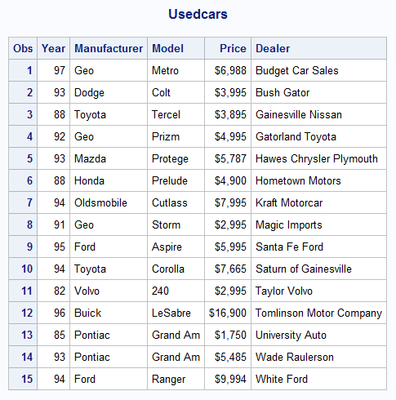

5

Code:

libname college 'C:\Users\Samil\Desktop\Sem 1\Stats for programming\SAS 9.4';

**data** college.noeggs;

set college.bread;

where eggs=**0**;

**run**;

Title 'Recipes with No Eggs';

**proc** **print** data=college.noeggs;

**run**;

Title;

Log file:

71 Title 'Recipes with No Eggs';

72

73 proc print data=college.noeggs;

74 run;

NOTE: There were 8 observations read from the data set COLLEGE.NOEGGS.

NOTE: PROCEDURE PRINT used (Total process time):

real time 0.08 seconds

cpu time 0.01 seconds

75

76 Title;

Output:

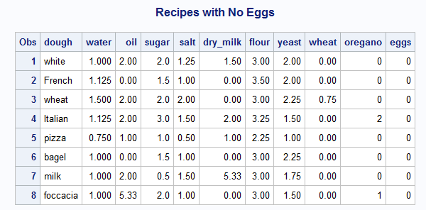

6

Code:

**data** college.clinton;

infile 'C:\Users\Samil\Desktop\Sem 1\Stats for programming\SAS 9.4\clinton.txt' firstobs=**2**;

input Day Mo $ Year Approve Disapprove No_opinion;

*mistakes=_error_;

if Mo='Jan' then Mo='1';

else if Mo='Feb' then Mo='2';

else if Mo='Mar' then Mo='3';

else if Mo='Apr' then Mo='4';

else if Mo='May' then Mo='5';

else if Mo='Jun' then Mo='6';

else if Mo='Jul' then Mo='7';

else if Mo='Aug' then Mo='8';

else if Mo='Sep' then Mo='9';

else if Mo='Oct' then Mo='10';

else if Mo='Nov' then Mo='11';

else if Mo='Dec' then Mo='12';

date=mdy(Mo,Day,Year);

*format date mmddyy8.;

**run**;

/*proc print data=college.clinton;

run;*/

**data** college.clinton1;

input Date mmddyy8. Approve Disapprove No_opinion;

*mistakes=_error_;

format Date mmddyy8.;

datalines;

8-18-98 66 29 5

8-20-98 61 34 5

8-21-98 62 35 3

9-1-98 62 33 5

9-10-98 60 37 3

9-11-98 63 34 3

;

**run**;

Title 'Clinton1';

**proc** **print** data=college.clinton1;

**run**;

Title;

**proc** **sort** data=college.clinton1;

by Date;

**run**;

**proc** **sort** data=college.clinton;

by Date;

**run**;

**data** clintonfinal;

merge college.clinton college.clinton1;

by Date;

drop year Mo Day;

format Date Date9.

run;

**proc** **sort** data=clintonfinal;

by Descending Date;

**run**;

Title 'Clinton Final';

**proc** **print** data=clintonfinal;

**run**;

Title;

Log file:

240 data college.clinton;

241 infile 'C:\Users\Samil\Desktop\Sem 1\Stats for programming\SAS 9.4\clinton.txt' firstobs=2;

242 input Day Mo $ Year Approve Disapprove No_opinion;

243 *mistakes=_error_;

244 if Mo='Jan' then Mo='1';

245 else if Mo='Feb' then Mo='2';

246 else if Mo='Mar' then Mo='3';

247 else if Mo='Apr' then Mo='4';

248 else if Mo='May' then Mo='5';

249 else if Mo='Jun' then Mo='6';

250 else if Mo='Jul' then Mo='7';

251 else if Mo='Aug' then Mo='8';

252 else if Mo='Sep' then Mo='9';

253 else if Mo='Oct' then Mo='10';

254 else if Mo='Nov' then Mo='11';

255 else if Mo='Dec' then Mo='12';

256 date=mdy(Mo,Day,Year);

257 *format date mmddyy8.;

258 run;

NOTE: Character values have been converted to numeric values at the places given by:

(Line):(Column).

256:11

NOTE: The infile 'C:\Users\Samil\Desktop\Sem 1\Stats for programming\SAS 9.4\clinton.txt' is:

Filename=C:\Users\Samil\Desktop\Sem 1\Stats for programming\SAS 9.4\clinton.txt,

RECFM=V,LRECL=32767,File Size (bytes)=6120,

Last Modified=01 October 2017 10:41:43,

Create Time=01 October 2017 10:41:41

NOTE: 141 records were read from the infile 'C:\Users\Samil\Desktop\Sem 1\Stats for

programming\SAS 9.4\clinton.txt'.

The minimum record length was 41.

The maximum record length was 49.

NOTE: SAS went to a new line when INPUT statement reached past the end of a line.

NOTE: The data set COLLEGE.CLINTON has 140 observations and 7 variables.

NOTE: DATA statement used (Total process time):

real time 0.02 seconds

cpu time 0.01 seconds

259

260 /*proc print data=college.clinton;

261 run;*/

262

263 data college.clinton1;

264 input Date mmddyy8. Approve Disapprove No_opinion;

265 *mistakes=_error_;

266 format Date mmddyy8.;

267 datalines;

NOTE: The data set COLLEGE.CLINTON1 has 6 observations and 4 variables.

NOTE: DATA statement used (Total process time):

real time 0.01 seconds

cpu time 0.01 seconds

274 ;

275 run;

276

277 Title 'Clinton1';

278

279 proc print data=college.clinton1;

280 run;

NOTE: There were 6 observations read from the data set COLLEGE.CLINTON1.

NOTE: PROCEDURE PRINT used (Total process time):

real time 0.08 seconds

cpu time 0.00 seconds

281

282 Title;

283

284 proc sort data=college.clinton1;

285 by Date;

286 run;

NOTE: There were 6 observations read from the data set COLLEGE.CLINTON1.

NOTE: The data set COLLEGE.CLINTON1 has 6 observations and 4 variables.

NOTE: PROCEDURE SORT used (Total process time):

real time 0.02 seconds

cpu time 0.00 seconds

287

288

289 proc sort data=college.clinton;

290 by Date;

291 run;

NOTE: There were 140 observations read from the data set COLLEGE.CLINTON.

NOTE: The data set COLLEGE.CLINTON has 140 observations and 7 variables.

NOTE: PROCEDURE SORT used (Total process time):

real time 0.02 seconds

cpu time 0.00 seconds

292

293 data clintonfinal;

294 merge college.clinton college.clinton1;

295 by Date;

296 drop year Mo Day;

297 format Date Date9.

298 run;

299

NOTE: Variable run is uninitialized.

NOTE: There were 140 observations read from the data set COLLEGE.CLINTON.

NOTE: There were 6 observations read from the data set COLLEGE.CLINTON1.

NOTE: The data set WORK.CLINTONFINAL has 146 observations and 4 variables.

NOTE: DATA statement used (Total process time):

real time 0.04 seconds

cpu time 0.03 seconds

300 proc sort data=clintonfinal;

301 by Descending Date;

302 run;

NOTE: There were 146 observations read from the data set WORK.CLINTONFINAL.

NOTE: The data set WORK.CLINTONFINAL has 146 observations and 4 variables.

NOTE: PROCEDURE SORT used (Total process time):

real time 0.02 seconds

cpu time 0.01 seconds

303

304 Title 'Clinton Final';

305

306 proc print data=clintonfinal;

307 run;

NOTE: There were 146 observations read from the data set WORK.CLINTONFINAL.

NOTE: PROCEDURE PRINT used (Total process time):

real time 0.18 seconds

cpu time 0.11 seconds

308 Title;

Output:

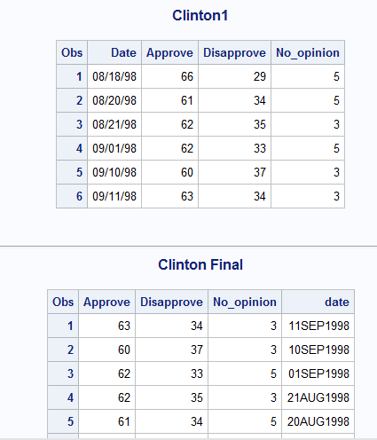

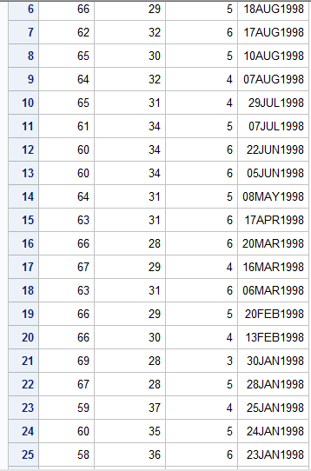

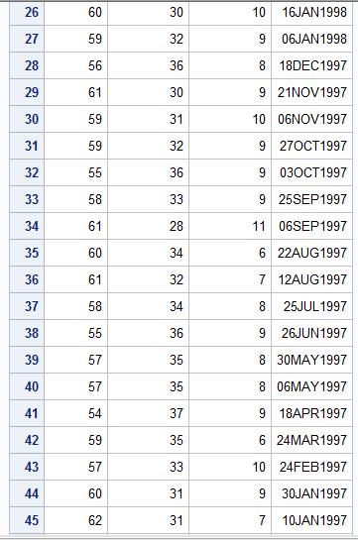

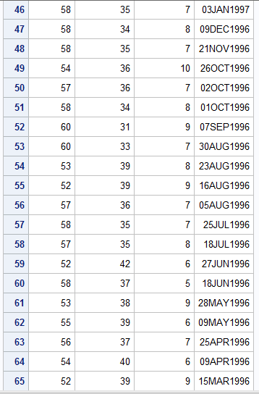

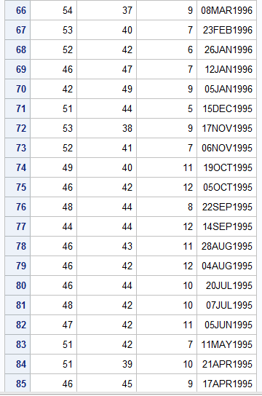

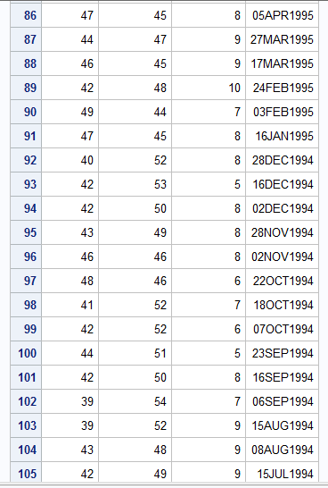

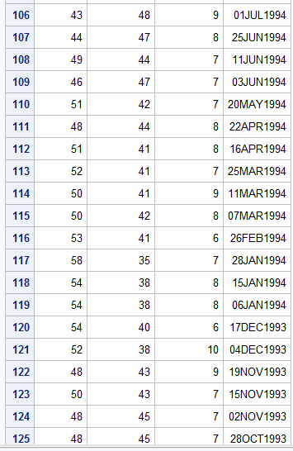

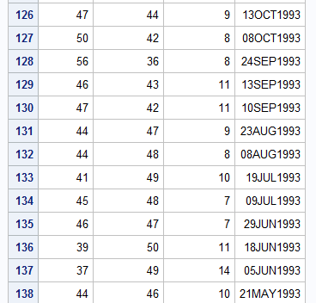

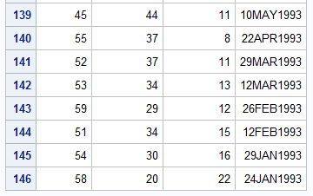

7

Code:

**data** college.blood;

infile 'C:\Users\Samil\Desktop\Sem 1\Stats for programming\SAS 9.4\blood.txt';

input Subject Gender $ Blood_Type $ Age_Group $ WBC RBC Cholesterol ;

**run**;

/*

Title 'Blood';

proc print data=college.blood;

run;

Title;*/

**data** subset_A;

set college.blood;

by subject;

comb=**0.001**\*WBC+RBC;

where Gender='Female' & Blood_Type='AB';

**run**;

Title 'Subset A';

**proc** **print** data=subset_A;

**run**;

Title;

**data** subset_B;

set college.blood;

by subject;

comb=**0.001**\*WBC+RBC;

where Gender='Female' & Blood_Type='AB';

**run**;

**data** subB;

set subset_B;

by subject;

where comb>=**14**;

**run**;

Title 'Subset B';

**proc** **print** data=subB;

**run**;

Title;

Log file:

128 data college.blood;

129 infile 'C:\Users\Samil\Desktop\Sem 1\Stats for programming\SAS 9.4\blood.txt';

130 input Subject Gender $ Blood_Type $ Age_Group $ WBC RBC Cholesterol ;

131 run;

NOTE: The infile 'C:\Users\Samil\Desktop\Sem 1\Stats for programming\SAS 9.4\blood.txt' is:

Filename=C:\Users\Samil\Desktop\Sem 1\Stats for programming\SAS 9.4\blood.txt,

RECFM=V,LRECL=32767,File Size (bytes)=37578,

Last Modified=01 October 2017 10:52:41,

Create Time=01 October 2017 10:52:40

NOTE: 1000 records were read from the infile 'C:\Users\Samil\Desktop\Sem 1\Stats for

programming\SAS 9.4\blood.txt'.

The minimum record length was 34.

The maximum record length was 36.

NOTE: The data set COLLEGE.BLOOD has 1000 observations and 7 variables.

NOTE: DATA statement used (Total process time):

real time 0.16 seconds

cpu time 0.03 seconds

132 /*

133 Title 'Blood';

134

135 proc print data=college.blood;

136 run;

137

138 Title;*/

139

140 data subset_A;

141 set college.blood;

142 by subject;

143 comb=0.001*WBC+RBC;

144 where Gender='Female' & Blood_Type='AB';

145 run;

NOTE: Missing values were generated as a result of performing an operation on missing values.

Each place is given by: (Number of times) at (Line):(Column).

2 at 143:12 1 at 143:16

NOTE: There were 20 observations read from the data set COLLEGE.BLOOD.

WHERE (Gender='Female') and (Blood_Type='AB');

NOTE: The data set WORK.SUBSET_A has 20 observations and 8 variables.

NOTE: DATA statement used (Total process time):

real time 0.04 seconds

cpu time 0.01 seconds

146

147 Title 'Subset A';

148

149 proc print data=subset_A;

150 run;

NOTE: There were 20 observations read from the data set WORK.SUBSET_A.

NOTE: PROCEDURE PRINT used (Total process time):

real time 0.47 seconds

cpu time 0.04 seconds

151 Title;

152

153 data subset_B;

154 set college.blood;

155 by subject;

156 comb=0.001*WBC+RBC;

157 where Gender='Female' & Blood_Type='AB';

158 run;

NOTE: Missing values were generated as a result of performing an operation on missing values.

Each place is given by: (Number of times) at (Line):(Column).

2 at 156:12 1 at 156:16

NOTE: There were 20 observations read from the data set COLLEGE.BLOOD.

WHERE (Gender='Female') and (Blood_Type='AB');

NOTE: The data set WORK.SUBSET_B has 20 observations and 8 variables.

NOTE: DATA statement used (Total process time):

real time 0.04 seconds

cpu time 0.01 seconds

159

160 data subB;

161 set subset_B;

162 by subject;

163 where comb>=14;

164 run;

NOTE: There were 4 observations read from the data set WORK.SUBSET_B.

WHERE comb>=14;

NOTE: The data set WORK.SUBB has 4 observations and 8 variables.

NOTE: DATA statement used (Total process time):

real time 0.01 seconds

cpu time 0.01 seconds

165

166 Title 'Subset B';

167

168 proc print data=subB;

169 run;

NOTE: There were 4 observations read from the data set WORK.SUBB.

NOTE: PROCEDURE PRINT used (Total process time):

real time 0.71 seconds

cpu time 0.01 seconds

170

171 Title;

Output:

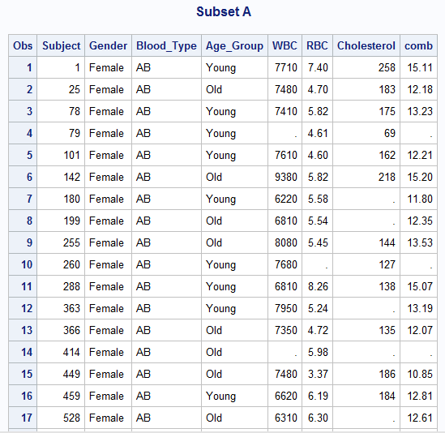

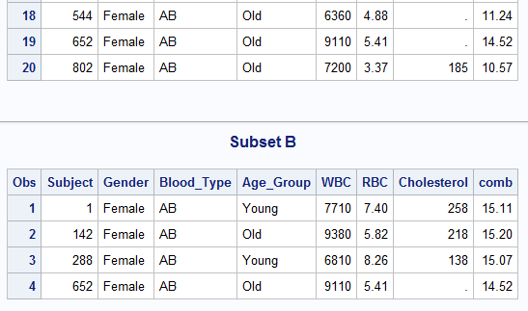

8

Code:

**data** lowmale lowfemale;

set college.blood;

by subject;

where Cholesterol<**100** & Cholesterol^=**.**;

if Gender='Male' then output lowmale;

else if Gender='Female' then output lowfemale;

**run**;

Title 'Males with Low Cholesterol';

**proc** **print** data=lowmale;

**run**;

Title;

Title 'Females with Low Cholesterol';

**proc** **print** data=lowfemale;

**run**;

Title;

Log file:

65 data lowmale lowfemale;

66 set college.blood;

67 by subject;

68 where Cholesterol<100 & Cholesterol^=.;

69 if Gender='Male' then output lowmale;

70 else if Gender='Female' then output lowfemale;

71 run;

NOTE: There were 12 observations read from the data set COLLEGE.BLOOD.

WHERE (Cholesterol<100) and (Cholesterol not = .);

NOTE: The data set WORK.LOWMALE has 8 observations and 7 variables.

NOTE: The data set WORK.LOWFEMALE has 4 observations and 7 variables.

NOTE: DATA statement used (Total process time):

real time 0.20 seconds

cpu time 0.00 seconds

72

73 Title 'Males with Low Cholesterol';

74

75 proc print data=lowmale;

76 run;

NOTE: There were 8 observations read from the data set WORK.LOWMALE.

NOTE: PROCEDURE PRINT used (Total process time):

real time 0.42 seconds

cpu time 0.01 seconds

77 Title;

78

79 Title 'Females with Low Cholesterol';

80

81 proc print data=lowfemale;

82 run;

NOTE: There were 4 observations read from the data set WORK.LOWFEMALE.

NOTE: PROCEDURE PRINT used (Total process time):

real time 0.98 seconds

cpu time 0.01 seconds

83 Title;

Output:

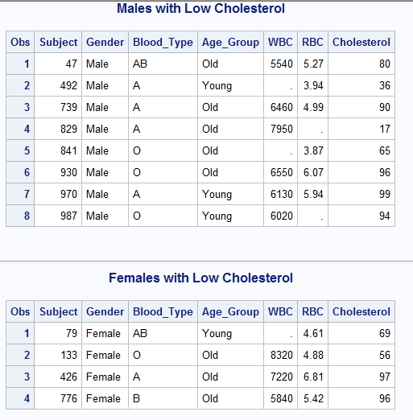

9

Code:

libname college 'C:\Users\Samil\Desktop\Sem 1\Stats for programming\SAS 9.4';

**proc** **print** data=college.bicycles;

**run**;

**data** Mountain_USA Road_France;

set college.bicycles;

if Country='USA' & Model='Mountain Bike' then output Mountain_USA;

else if Country='France' & Model='Road Bike' then output Road_France;

**run**;

Title 'Mountain USA';

**proc** **print** data=Mountain_USA;

**run**;

Title;

Title 'Road France';

**proc** **print** data=Road_France;

**run**;

Title;

Log file:

21 libname college 'C:\Users\Samil\Desktop\Sem 1\Stats for programming\SAS 9.4';

NOTE: Libref COLLEGE was successfully assigned as follows:

Engine: V9

Physical Name: C:\Users\Samil\Desktop\Sem 1\Stats for programming\SAS 9.4

22 proc print data=college.bicycles;

23 run;

NOTE: There were 18 observations read from the data set COLLEGE.BICYCLES.

NOTE: PROCEDURE PRINT used (Total process time):

real time 0.98 seconds

cpu time 0.06 seconds

24

25 data Mountain_USA Road_France;

26 set college.bicycles;

27 if Country='USA' & Model='Mountain Bike' then output Mountain_USA;

28 else if Country='France' & Model='Road Bike' then output Road_France;

29 run;

NOTE: There were 18 observations read from the data set COLLEGE.BICYCLES.

NOTE: The data set WORK.MOUNTAIN_USA has 2 observations and 6 variables.

NOTE: The data set WORK.ROAD_FRANCE has 2 observations and 6 variables.

NOTE: DATA statement used (Total process time):

real time 0.17 seconds

cpu time 0.06 seconds

30

31 Title 'Mountain USA';

32

33 proc print data=Mountain_USA;

34 run;

NOTE: There were 2 observations read from the data set WORK.MOUNTAIN_USA.

NOTE: PROCEDURE PRINT used (Total process time):

real time 0.40 seconds

cpu time 0.01 seconds

35 Title;

36

37 Title 'Road France';

38

39 proc print data=Road_France;

40 run;

NOTE: There were 2 observations read from the data set WORK.ROAD_FRANCE.

NOTE: PROCEDURE PRINT used (Total process time):

real time 0.12 seconds

cpu time 0.01 seconds

41 Title;

Output:

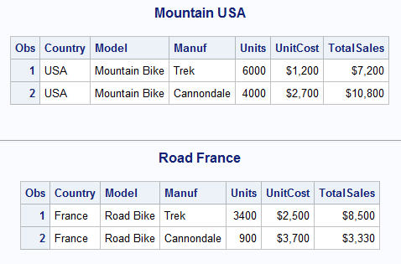

10

Code:

libname college 'C:\Users\Samil\Desktop\Sem 1\Stats for programming\SAS 9.4';

Title 'Inventory';

**proc** **print** data=college.inventory;

**run**;

Title;

Title 'New Products';

**proc** **print** data=college.newproducts;

**run**;

Title;

Title 'Products';

**data** products;

set college.inventory college.newproducts;

**run**;

**proc** **sort** data=products;

by model;

**run**;

**proc** **print** data=products;

**run**;

Title;

Log file:

15 Title 'Inventory';

16

17 proc print data=college.inventory;

18 run;

NOTE: There were 6 observations read from the data set COLLEGE.INVENTORY.

NOTE: PROCEDURE PRINT used (Total process time):

real time 0.15 seconds

cpu time 0.00 seconds

19

20 Title;

21

22 Title 'New Products';

23

24 proc print data=college.newproducts;

25 run;

NOTE: There were 2 observations read from the data set COLLEGE.NEWPRODUCTS.

NOTE: PROCEDURE PRINT used (Total process time):

real time 0.14 seconds

cpu time 0.01 seconds

26

27 Title;

28

29

30 Title 'Products';

31

32 data products;

33 set college.inventory college.newproducts;

34 run;

NOTE: There were 6 observations read from the data set COLLEGE.INVENTORY.

NOTE: There were 2 observations read from the data set COLLEGE.NEWPRODUCTS.

NOTE: The data set WORK.PRODUCTS has 8 observations and 2 variables.

NOTE: DATA statement used (Total process time):

real time 0.05 seconds

cpu time 0.03 seconds

35

36

37 proc sort data=products;

38 by model;

39 run;

NOTE: There were 8 observations read from the data set WORK.PRODUCTS.

NOTE: The data set WORK.PRODUCTS has 8 observations and 2 variables.

NOTE: PROCEDURE SORT used (Total process time):

real time 0.41 seconds

cpu time 0.03 seconds

40

41 proc print data=products;

42 run;

NOTE: There were 8 observations read from the data set WORK.PRODUCTS.

NOTE: PROCEDURE PRINT used (Total process time):

real time 0.28 seconds

cpu time 0.01 seconds

43

44 Title;

Output:

